**DESIGNED BY:**

* ANKITA KINDO (L3189)
* ANUSAYA SAHOO (L3196)
* REET NAYAK (L3103)
* SAMODARI BHUMIJ (L3102)
* SAMRIDHI SHARMA (L3090)
* VIKAS KUMAR (L3432)

**UNDER THE GUIDENCE OF:**

**Mr. KISHAN SHARMA**

**CONTENTS**

* ACKNOWLEDGEMENT
* CERTIFICATE
* INTRODUCTION
* TECHNOLOGIES USED
* FLOW CHART DIAGRAM
* SOURCE CODE
* WEBPAGE OUTPUT SCREENSHOT
* CONCLUSION
* BIBILIOGRAPHY

**ACKNOWLEDGEMENT**

First of all, we would like to mention the contribution of SeeNet Consultancy Services Pvt. Ltd. for the development and application domain.

We respect and thank to **Mr. Kishan Sharma** sir for providing us an opportunity to do the project work in SeeNet and giving us all support and guidance which made us complete the project duty.

We would like to thank each and every member of our group for their participation, support and guidance which helped us in completing our project work successfully.

**CERTIFICATE**

This to certify the following students:

* ANKITA KINDO (L3189)
* ANUSAYA SAHOO (L3196)
* REET NAYAK (L3103)
* SAMODARI BHUMIJ (L3102)
* SAMRIDHI SHARMA (L3090)
* VIKAS KUMAR (L3432)

Of “SeeNet Computer Institute” has completed the web Designing Project, titled with “ONLINE SHOPPING SITE” during the academic year 2021-2022 towards partial fulfilment to credit for the Computer Science Project Evaluation of HTML & CSS at SeeNet Consultancy Services Pvt. Ltd., STPI Complex, Rourkela-769002.

They have submitted satisfactory report, as complied in the following pages, under professional supervision.

(Student’s Project Co-ordinate)

SeeNet Consultancy Services Pvt. Ltd.

**INTRODUCTION**

This Project Online Shopping Site has been developed on HTML and CSS. We develop html projects with source code who want to use html projects to learn.

The main objective of developing this project was to create a static website for the shopping, from which user can get the complete details of the Online Shopping Site, New arrivals, Recent Order’s etc.

This project is in HTML and CSS so it’s a static website and does not perform any type of dynamic database operations.

Pages of the project Online Shopping Site:

* **Home Page:** This page contains the basic information about the shopping site like we have linked home page to all other web pages, & we can go directly by clicking to them via navigation menu.
* **Products:** This page contains different types of sports products. like, shoes, tracks, etc.
* **About:** The purpose of this page is to inform the reader about the company and its operations.
* **Contact:** This page shows the information about project administrator. Here, you can give your feedbacks or any complaints about products.
* **Account:** Here you can register yourself or login by providing contact no for better deals.
* **Cart:** Allow customers to save items to their cart so they can continue shopping, then complete the checkout process later on in the process.

**TECHNOLOGIES USED**

We have developed this project using the below technology:-

* HTML Page Layout has been designed in Html.
* CSS: CSS has been used for the designing part.
* Adobe Photoshop: By Photoshop we designed our website logo.
* Web browser: By web browser we have selected our images according to our webpage.

**WEBPAGE FLOW CHART**

**Welcome to Online Shopping Site:**

Web Client

Online Shopping Site

Index.html

Products.html

About.html

Contact.html

Account.html

Cart.html

**Index.html**

Home Page

Navigation Menu

Advertisement

Featured Products

Latest Products

Brands

Ratings & Reviews

**Product.html**

Products

All Products

Product Details html

Default Sorting

Next pages

**About.html**

About

Who we are

Our Positions

Our Awards & Recognition

Our Leadership Principles

**Contact .html**

Contact

User Contact

Details (form)

Reach Us

**Account.html**

Products

Register

Login

**Cart.html**

Cart

Product

Quantity

Total

**SOURCE CODE**

**Index.html**

<html>

<head>

<title>Home</title>

<link rel="stylesheet" href="Css/Stylesheet44.css">

<link rel="preconnect" href="https://fonts.googleapis.com">

<link rel="preconnect" href="https://fonts.gstatic.com" crossorigin>

<link href="https://fonts.googleapis.com/css2?family=Anton&family=Baloo+Bhai+2:wght@500&family=Baloo+Bhaijaan+2:wght@700&family=Poppins:wght@300;400;500;600;700&family=Ubuntu:wght@500&display=swap" rel="stylesheet">

<link rel="stylesheet" href="https://stackpath.bootstrapcdn.com/font-awesome/4.7.0/css/font-awesome.min.css">

</head>

<body>

<div class="header">

<div class="container">

<div class="navbar">

<div class="logo">

<a href="index.html"><img src="img/logo2.png" width="125px"></a>

</div>

<nav>

<ul>

<li><a href="index.html">Home</a></li>

<li><a href="html/product.html">Products</a></li>

<li><a href="html/about us.html">About</a></li>

<li><a href="html/contact us.html">Contact</a></li>

<li><a href="html/account.html">Account</a></li>

</ul>

</nav>

<a href="html/cart.html"><img src="img/cart.png" width="30px" height="30px"></a>

<img src="img/menu.png" class="menu-icon">

</div>

<div class="row">

<div class="col-2">

<h1>Give Your Workout<br> A New Style!</h1>

<p>Success isn't always about greatness. It's about consistency. Consistent <br>hard work gains success. Greatness will come.</p>

<a href="" class="btn">Explore Now &#8594;</a>

</div>

<div class="col-2">

<img src="img/football.png">

</div>

</div>

</div>

</div>

<div class="categories">

<div class="small-container">

<div class="row">

<div class="col-3">

<img src="img/category1.jpg">

</div>

<div class="col-3">

<img src="img/category2.jpg">

</div>

<div class="col-3">

<img src="img/category3.jpg">

</div>

</div>

</div>

</div>

<div class="small-container">

<h2 class="title">Featured Products</h2>

<div class="row">

<div class="col-4">

<img src="img/product-1.jpg">

<h4>Red Printed T-Shirt</h4>

<div class="rating">

<i class="fa fa-star"></i>

<i class="fa fa-star"></i>

<i class="fa fa-star"></i>

<i class="fa fa-star"></i>

<i class="fa fa-star-o"></i>

</div>

<p>Rs599.00</p>

</div>

<div class="col-4">

<img src="img/product-2.jpg">

<h4>HRX Walking Shoes For Men</h4>

<div class="rating">

<i class="fa fa-star"></i>

<i class="fa fa-star"></i>

<i class="fa fa-star"></i>

<i class="fa fa-star-half-o"></i>

<i class="fa fa-star-o"></i>

</div>

<p>Rs1,609.00</p>

</div>

<div class="col-4">

<img src="img/product-3.jpg">

<h4>Black Casual Trackpant</h4>

<div class="rating">

<i class="fa fa-star"></i>

<i class="fa fa-star"></i>

<i class="fa fa-star"></i>

<i class="fa fa-star"></i>

<i class="fa fa-star-half-o"></i>

</div>

<p>Rs1,099.00</p>

</div>

<div class="col-4">

<img src="img/product-4.jpg">

<h4>Puma Black Casual T-Shirt</h4>

<div class="rating">

<i class="fa fa-star"></i>

<i class="fa fa-star"></i>

<i class="fa fa-star"></i>

<i class="fa fa-star"></i>

<i class="fa fa-star-o"></i>

</div>

<p>Rs1,399.00</p>

</div>

</div>

<h2 class="title">Latest Products</h2>

<div class="row">

<div class="col-4">

<img src="img/product-5.jpg">

<h4>Casual Shoes For Men</h4>

<div class="rating">

<i class="fa fa-star"></i>

<i class="fa fa-star"></i>

<i class="fa fa-star"></i>

<i class="fa fa-star"></i>

<i class="fa fa-star-o"></i>

</div>

<p>Rs899.00</p>

</div>

<div class="col-4">

<img src="img/product-6.jpg">

<h4>Puma Black T-Shirt</h4>

<div class="rating">

<i class="fa fa-star"></i>

<i class="fa fa-star"></i>

<i class="fa fa-star"></i>

<i class="fa fa-star-half-o"></i>

<i class="fa fa-star-o"></i>

</div>

<p>Rs1,399.00</p>

</div>

<div class="col-4">

<img src="img/product-7.jpg">

<h4>HRX Formal Socks For Unisex</h4>

<div class="rating">

<i class="fa fa-star"></i>

<i class="fa fa-star"></i>

<i class="fa fa-star"></i>

<i class="fa fa-star"></i>

<i class="fa fa-star-half-o"></i>

</div>

<p>Rs899.00</p>

</div>

<div class="col-4">

<img src="img/product-8.jpg">

<h4>Fossil Decker Watch For Men</h4>

<div class="rating">

<i class="fa fa-star"></i>

<i class="fa fa-star"></i>

<i class="fa fa-star"></i>

<i class="fa fa-star"></i>

<i class="fa fa-star-o"></i>

</div>

<p>Rs10,999.00</p>

</div>

<div class="row">

<div class="col-4">

<img src="img/product-9.jpg">

<h4>Casual Watch For Unisex</h4>

<div class="rating">

<i class="fa fa-star"></i>

<i class="fa fa-star"></i>

<i class="fa fa-star"></i>

<i class="fa fa-star"></i>

<i class="fa fa-star-o"></i>

</div>

<p>Rs999.00</p>

</div>

<div class="col-4">

<img src="img/product-10.jpg">

<h4>HRX Walking Shoes For Men</h4>

<div class="rating">

<i class="fa fa-star"></i>

<i class="fa fa-star"></i>

<i class="fa fa-star"></i>

<i class="fa fa-star-half-o"></i>

<i class="fa fa-star-o"></i>

</div>

<p>Rs2,089.00</p>

</div>

<div class="col-4">

<img src="img/product-11.jpg">

<h4>Grey Casual Shoes For Men</h4>

<div class="rating">

<i class="fa fa-star"></i>

<i class="fa fa-star"></i>

<i class="fa fa-star"></i>

<i class="fa fa-star"></i>

<i class="fa fa-star-half-o"></i>

</div>

<p>Rs1,199.00</p>

</div>

<div class="col-4">

<img src="img/product-12.jpg">

<h4>Nike Black Trackpant For Men</h4>

<div class="rating">

<i class="fa fa-star"></i>

<i class="fa fa-star"></i>

<i class="fa fa-star"></i>

<i class="fa fa-star"></i>

<i class="fa fa-star-o"></i>

</div>

<p>Rs3,399.00</p>

</div>

</div>

</div>

</div>

<div class="offer">

<div class="small-container">

<div class="row">

<div class="col-2">

<img src="img/exclusive.png" class="offer-img">

</div>

<div class="col-2">

<p>Exclusively Available on RedStore</p>

<h1>Smart Band 4</h1>

<small>The Mi Smart Band 4 features a 39.9% larger (than Mi Band 3) AMOLED color full-touch display with adjustable brightness, so everything is clear as can be.<br></small>

<a href="" class="btn">Buy Now &#8594;</a>

</div>

</div>

</div>

</div>

<div class="testimonial">

<div class="small-container">

<div class="row">

<div class="col-3">

<i class="fa fa-quote-left"></i>

<p>Lorem Ipsum is simply dummy text of the printing and typesetting industry. Lorem Ipsum has been the industry's standard dummy text ever</p>

<div class="rating">

<i class="fa fa-star"></i>

<i class="fa fa-star"></i>

<i class="fa fa-star"></i>

<i class="fa fa-star"></i>

<i class="fa fa-star-o"></i>

</div>

<img src="img/user-1.png">

<h3>Sean Parker</h3>

</div>

<div class="col-3">

<i class="fa fa-quote-left"></i>

<p>Lorem Ipsum is simply dummy text of the printing and typesetting industry. Lorem Ipsum has been the industry's standard dummy text ever</p>

<div class="rating">

<i class="fa fa-star"></i>

<i class="fa fa-star"></i>

<i class="fa fa-star"></i>

<i class="fa fa-star"></i>

<i class="fa fa-star-o"></i>

</div>

<img src="img/user-2.png">

<h3>Mike Smith</h3>

</div>

<div class="col-3">

<i class="fa fa-quote-left"></i>

<p>Lorem Ipsum is simply dummy text of the printing and typesetting industry. Lorem Ipsum has been the industry's standard dummy text ever</p>

<div class="rating">

<i class="fa fa-star"></i>

<i class="fa fa-star"></i>

<i class="fa fa-star"></i>

<i class="fa fa-star"></i>

<i class="fa fa-star-o"></i>

</div>

<img src="img/user-3.png">

<h3>Mabel Joe</h3>

</div>

</div>

</div>

</div>

<div class="brands">

<div class="small-container">

<div class="row">

<div class="col-5">

<img src="img/logo-godrej.png">

</div>

<div class="col-5">

<img src="img/logo-oppo.png">

</div>

<div class="col-5">

<img src="img/logo-coca-cola.png">

</div>

<div class="col-5">

<img src="img/logo-paypal.png">

</div>

<div class="col-5">

<img src="img/logo-philips.png">

</div>

</div>

</div>

</div>

<div class="footer">

<div class="container">

<div class="row">

<div class="footer-col-1">

<h3>Download Our App</h3>

<p>Download App for Android and Ios mobile phones.</p>

<div class="app-logo">

<img src="img/play-store.png">

<img src="img/app-store.png">

</div>

</div>

<div class="footer-col-2">

<img src="img/logo-white.png">

<p>Our Purpose is to Sustainably make the Pleasure and Benefits of Sports Accessible to the Many.</p>

</div>

<div class="footer-col-3">

<h3>Useful Links</h3>

<ul>

<li>Coupons</li>

<li>Blog Post</li>

<li>Return Policy</li>

<li>Join Affiliate</li>

</ul>

</div>

<div class="footer-col-4">

<h3>Follow us</h3>

<ul>

<li>Facebook</li>

<li>Twitter</li>

<li>Instagram</li>

<li>YouTube</li>

</ul>

</div>

</div>

<hr>

<p class="copyright">Copyright 2022 - Rn Officials</p>

</div>

</div>

</body>

</html>

**Product.html**

<html>

<head>

<title>All Products - Redstore</title>

<link rel="stylesheet" href="../Css/Stylesheet44.css">

<link rel="preconnect" href="https://fonts.googleapis.com">

<link rel="preconnect" href="https://fonts.gstatic.com" crossorigin>

<link href="https://fonts.googleapis.com/css2?family=Anton&family=Baloo+Bhai+2:wght@500&family=Baloo+Bhaijaan+2:wght@700&family=Poppins:wght@300;400;500;600;700&family=Ubuntu:wght@500&display=swap" rel="stylesheet">

<link rel="stylesheet" href="https://stackpath.bootstrapcdn.com/font-awesome/4.7.0/css/font-awesome.min.css">

</head>

<body>

<div class="container">

<div class="navbar">

<div class="logo">

<a href="../index.html"><img src="../img/logo2.png" width="125px"></a>

</div>

<nav>

<ul>

<li><a href="../index.html">Home</a></li>

<li><a href="product.html">Products</a></li>

<li><a href="about us.html">About</a></li>

<li><a href="contact us.html">Contact</a></li>

<li><a href="account.html">Account</a></li>

</ul>

</nav>

<a href="cart.html"><img src="../img/cart.png" width="30px" height="30px"></a>

<img src="../img/menu.png" class="menu-icon">

</div>

</div>

<div class="small-container">

<div class="row row-2">

<h2>All Products</h2>

<select>

<option>Default Sorting</option>

<option>Sort by price</option>

<option>Sort by popularity</option>

<option>Sort by rating</option>

<option>Sort by sale</option>

</select>

</div>

<div class="row">

<div class="col-4">

<a href="product detail.html"><img src="../img/product-1.jpg">

<h4>Red Printed T-Shirt</h4>

<div class="rating">

<i class="fa fa-star"></i>

<i class="fa fa-star"></i>

<i class="fa fa-star"></i>

<i class="fa fa-star"></i>

<i class="fa fa-star-o"></i>

</div>

<p>Rs599.00</p>

</div>

</a>

<div class="col-4">

<img src="../img/product-2.jpg">

<h4>HRX Walking Shoes For Men</h4>

<div class="rating">

<i class="fa fa-star"></i>

<i class="fa fa-star"></i>

<i class="fa fa-star"></i>

<i class="fa fa-star-half-o"></i>

<i class="fa fa-star-o"></i>

</div>

<p>Rs1,609.00</p>

</div>

<div class="col-4">

<img src="../img/product-3.jpg">

<h4>Black Casual Trackpant</h4>

<div class="rating">

<i class="fa fa-star"></i>

<i class="fa fa-star"></i>

<i class="fa fa-star"></i>

<i class="fa fa-star"></i>

<i class="fa fa-star-half-o"></i>

</div>

<p>Rs1,099.00</p>

</div>

<div class="col-4">

<img src="../img/product-4.jpg">

<h4>Puma Black Casual T-Shirt</h4>

<div class="rating">

<i class="fa fa-star"></i>

<i class="fa fa-star"></i>

<i class="fa fa-star"></i>

<i class="fa fa-star"></i>

<i class="fa fa-star-o"></i>

</div>

<p>Rs1,399.00</p>

</div>

</div>

<div class="row">

<div class="col-4">

<img src="../img/product-5.jpg">

<h4>Casual Shoes For Men</h4>

<div class="rating">

<i class="fa fa-star"></i>

<i class="fa fa-star"></i>

<i class="fa fa-star"></i>

<i class="fa fa-star"></i>

<i class="fa fa-star-o"></i>

</div>

<p>Rs899.00</p>

</div>

<div class="col-4">

<img src="../img/product-6.jpg">

<h4>Puma Black T-Shirt</h4>

<div class="rating">

<i class="fa fa-star"></i>

<i class="fa fa-star"></i>

<i class="fa fa-star"></i>

<i class="fa fa-star-half-o"></i>

<i class="fa fa-star-o"></i>

</div>

<p>Rs1,399.00</p>

</div>

<div class="col-4">

<img src="../img/product-7.jpg">

<h4>HRX Formal Socks For Unisex</h4>

<div class="rating">

<i class="fa fa-star"></i>

<i class="fa fa-star"></i>

<i class="fa fa-star"></i>

<i class="fa fa-star"></i>

<i class="fa fa-star-half-o"></i>

</div>

<p>Rs899.00</p>

</div>

<div class="col-4">

<img src="../img/product-8.jpg">

<h4>Fossil Decker Watch For Men</h4>

<div class="rating">

<i class="fa fa-star"></i>

<i class="fa fa-star"></i>

<i class="fa fa-star"></i>

<i class="fa fa-star"></i>

<i class="fa fa-star-o"></i>

</div>

<p>Rs10,999.00</p>

</div>

<div class="row">

<div class="col-4">

<img src="../img/product-9.jpg">

<h4>Casual Watch For Unisex</h4>

<div class="rating">

<i class="fa fa-star"></i>

<i class="fa fa-star"></i>

<i class="fa fa-star"></i>

<i class="fa fa-star"></i>

<i class="fa fa-star-o"></i>

</div>

<p>Rs999.00</p>

</div>

<div class="col-4">

<img src="../img/product-10.jpg">

<h4>HRX Walking Shoes For Men</h4>

<div class="rating">

<i class="fa fa-star"></i>

<i class="fa fa-star"></i>

<i class="fa fa-star"></i>

<i class="fa fa-star-half-o"></i>

<i class="fa fa-star-o"></i>

</div>

<p>Rs2,089.00</p>

</div>

<div class="col-4">

<img src="../img/product-11.jpg">

<h4>Grey Casual Shoes For Men</h4>

<div class="rating">

<i class="fa fa-star"></i>

<i class="fa fa-star"></i>

<i class="fa fa-star"></i>

<i class="fa fa-star"></i>

<i class="fa fa-star-half-o"></i>

</div>

<p>Rs1,199.00</p>

</div>

<div class="col-4">

<img src="../img/product-12.jpg">

<h4>Nike Black Trackpant For Men</h4>

<div class="rating">

<i class="fa fa-star"></i>

<i class="fa fa-star"></i>

<i class="fa fa-star"></i>

<i class="fa fa-star"></i>

<i class="fa fa-star-o"></i>

</div>

<p>Rs3,399.00</p>

</div>

</div>

</div>

<div class="page-btn">

<span>1</span>

<span>2</span>

<span>3</span>

<span>4</span>

<span>&#8594;</span>

</div>

</div>

<div class="footer">

<div class="container">

<div class="row">

<div class="footer-col-1">

<h3>Download Our App</h3>

<p>Download App for Android and Ios mobile phones.</p>

<div class="app-logo">

<img src="../img/play-store.png">

<img src="../img/app-store.png">

</div>

</div>

<div class="footer-col-2">

<img src="../img/logo-white.png">

<p>Our Purpose is to Sustainably make the Pleasure and Benefits of Sports Accessible to the Many.</p>

</div>

<div class="footer-col-3">

<h3>Useful Links</h3>

<ul>

<li>Coupons</li>

<li>Blog Post</li>

<li>Return Policy</li>

<li>Join Affiliate</li>

</ul>

</div>

<div class="footer-col-4">

<h3>Follow us</h3>

<ul>

<li>Facebook</li>

<li>Twitter</li>

<li>Instagram</li>

<li>YouTube</li>

</ul>

</div>

</div>

<hr>

<p class="copyright">Copyright 2022 - Rn Officials</p>

</div>

</div>

</body>

</html>

**Product Detail.html**

<html>

<head>

<title>Product detail</title>

<link rel="stylesheet" href="../Css/Stylesheet44.css">

<link rel="preconnect" href="https://fonts.googleapis.com">

<link rel="preconnect" href="https://fonts.gstatic.com" crossorigin>

<link href="https://fonts.googleapis.com/css2?family=Anton&family=Baloo+Bhai+2:wght@500&family=Baloo+Bhaijaan+2:wght@700&family=Poppins:wght@300;400;500;600;700&family=Ubuntu:wght@500&display=swap" rel="stylesheet">

<link rel="stylesheet" href="https://stackpath.bootstrapcdn.com/font-awesome/4.7.0/css/font-awesome.min.css">

</head>

<body>

<div class="container">

<div class="navbar">

<div class="logo">

<a href="../index.html"><img src="../img/logo2.png" width="125px"></a>

</div>

<nav>

<ul>

<li><a href="../index.html">Home</a></li>

<li><a href="product.html">Products</a></li>

<li><a href="about us.html">About</a></li>

<li><a href="contact us.html">Contact</a></li>

<li><a href="account.html">Account</a></li>

</ul>

</nav>

<a href="cart.html"><img src="../img/cart.png" width="30px" height="30px"></a>

<img src="../img/menu.png" class="menu-icon">

</div>

</div>

<div class="small-container single-product">

<div class="row">

<div class="col-2">

<img src="../img/gallery-1.jpg" width="100%" id="productimg">

<div class="small-img-row">

<div class="small-img-col">

<img src="../img/gallery-1.jpg" width="100%" class="small-img">

</div>

<div class="small-img-col">

<img src="../img/gallery-2.jpg" width="100%" class="small-img">

</div>

<div class="small-img-col">

<img src="../img/gallery-3.jpg" width="100%" class="small-img">

</div>

<div class="small-img-col">

<img src="../img/gallery-4.jpg" width="100%" class="small-img">

</div>

</div>

</div>

<div class="col-2">

<p>Home / T-Shirt</p>

<h1>Red Printed T-Shirt by HRX</h1>

<h4>Rs599.00</h4>

<select>

<option>Select Size</option>

<option>XXL</option>

<option>XL</option>

<option>L</option>

<option>M</option>

<option>S</option>

</select>

<input type="number" value="1">

<a href="" class="btn">Add To Cart</a>

<h3>Product Details <i class="fa fa-indent"></i></h3>

<br>

<p>Give your summer wardrobe a style upgrade with the HRX Men's Active T-Shirt. Team it with a pair of shorts for your morning workout or a denims for an evening out with the guys.</p>

</div>

</div>

</div>

<div class="small-container">

<div class="row row-2">

<h2>Related Products</h2>

<p>View More</p>

</div>

</div>

<div class="small-container">

<div class="row">

<div class="col-4">

<img src="../img/product-9.jpg">

<h4>Casual Watch For Unisex</h4>

<div class="rating">

<i class="fa fa-star"></i>

<i class="fa fa-star"></i>

<i class="fa fa-star"></i>

<i class="fa fa-star"></i>

<i class="fa fa-star-o"></i>

</div>

<p>Rs999.00</p>

</div>

<div class="col-4">

<img src="../img/product-10.jpg">

<h4>HRX Walking Shoes For Men</h4>

<div class="rating">

<i class="fa fa-star"></i>

<i class="fa fa-star"></i>

<i class="fa fa-star"></i>

<i class="fa fa-star-half-o"></i>

<i class="fa fa-star-o"></i>

</div>

<p>Rs2,089.00</p>

</div>

<div class="col-4">

<img src="../img/product-11.jpg">

<h4>Grey Casual Shoes For Men</h4>

<div class="rating">

<i class="fa fa-star"></i>

<i class="fa fa-star"></i>

<i class="fa fa-star"></i>

<i class="fa fa-star"></i>

<i class="fa fa-star-half-o"></i>

</div>

<p>Rs1,199.00</p>

</div>

<div class="col-4">

<img src="../img/product-12.jpg">

<h4>Nike Black Trackpant For Men</h4>

<div class="rating">

<i class="fa fa-star"></i>

<i class="fa fa-star"></i>

<i class="fa fa-star"></i>

<i class="fa fa-star"></i>

<i class="fa fa-star-o"></i>

</div>

<p>Rs3,399.00</p>

</div>

</div>

</div>

</div>

<div class="footer">

<div class="container">

<div class="row">

<div class="footer-col-1">

<h3>Download Our App</h3>

<p>Download App for Android and Ios mobile phones.</p>

<div class="app-logo">

<img src="../img/play-store.png">

<img src="../img/app-store.png">

</div>

</div>

<div class="footer-col-2">

<img src="../img/logo-white.png">

<p>Our Purpose is to Sustainably make the Pleasure and Benefits of Sports Accessible to the Many.</p>

</div>

<div class="footer-col-3">

<h3>Useful Links</h3>

<ul>

<li>Coupons</li>

<li>Blog Post</li>

<li>Return Policy</li>

<li>Join Affiliate</li>

</ul>

</div>

<div class="footer-col-4">

<h3>Follow us</h3>

<ul>

<li>Facebook</li>

<li>Twitter</li>

<li>Instagram</li>

<li>YouTube</li>

</ul>

</div>

</div>

<hr>

<p class="copyright">Copyright 2022 - Rn Officials</p>

</div>

</div>

<script>

var productimg = document.getElementById("productimg");

var smallimg = document.getElementsByClassName("small-img");

smallimg[0].onclick = function()

{

productimg.src = smallimg[0].src;

}

smallimg[1].onclick = function()

{

productimg.src = smallimg[1].src;

}

smallimg[2].onclick = function()

{

productimg.src = smallimg[2].src;

}

smallimg[3].onclick = function()

{

productimg.src = smallimg[3].src;

}

</script>

</body>

</html>

**About.html**

<html>

<head>

<title>About us</title>

<link rel="stylesheet" href="../Css/Stylesheet44.css">

<link rel="preconnect" href="https://fonts.googleapis.com">

<link rel="preconnect" href="https://fonts.gstatic.com" crossorigin>

<link href="https://fonts.googleapis.com/css2?family=Anton&family=Baloo+Bhai+2:wght@500&family=Baloo+Bhaijaan+2:wght@700&family=Poppins:wght@300;400;500;600;700&family=Ubuntu:wght@500&display=swap" rel="stylesheet">

<link rel="stylesheet" href="https://stackpath.bootstrapcdn.com/font-awesome/4.7.0/css/font-awesome.min.css">

</head>

<body>

<div class="container">

<div class="navbar">

<div class="logo">

<a href="../index.html"><img src="../img/logo2.png" width="125px"></a>

</div>

<nav>

<ul>

<li><a href="../index.html">Home</a></li>

<li><a href="product.html">Products</a></li>

<li><a href="about us.html">About</a></li>

<li><a href="contact us.html">Contact</a></li>

<li><a href="account.html">Account</a></li>

</ul>

</nav>

<a href="cart.html"><img src="../img/cart.png" width="30px" height="30px"></a>

<img src="../img/menu.png" class="menu-icon">

</div>

</div>

<div class="section">

<div class="container">

<div class="content-section">

<div class="title">

<h1>About Us</h1>

</div>

<div class="content">

<h3>Who we are</h3>

<p>RedStore is guided by four principles: customer obsession rather than competitor focus,passion for invention, commitment to operational excellence, and long-term thinking. RedStore strives to be Earth's most customer-centric company, Earth's best employer, and Earth's safest place to work.</p>

</div>

<div class="content">

<h3>Our Leadership Principles</h3>

<p>Our Leadership Principles are more than inspirational wall hangings. The 16 priciples guide our discussion and decisions every day. We hold ourselves and each other accountable for demonstrating the Leadership Principles through our actions every day. Our Leadership Principles describe how RedStore does business, how leaders lead, and how we keep the customers at the center of our decisions.</p>

</div>

<div class="content">

<h3>Our Positions</h3>

<p>While our positions are carefully considered and deeply held, there is much room for healthy debate and differing opinions. We hope being clear about our positions is helpful.</p>

</div>

<div class="content">

<h3>Our Awards and Recognition</h3>

<p>We are honored to be recognized for the work we do on behalf of our customers, employees, and communities every day.</p>

<a href="" class="btn">Read More &#8594;</a>

</div>

</div>

</div>

</div>

<div class="footer">

<div class="container">

<div class="row">

<div class="footer-col-1">

<h3>Download Our App</h3>

<p>Download App for Android and Ios mobile phones.</p>

<div class="app-logo">

<img src="../img/play-store.png">

<img src="../img/app-store.png">

</div>

</div>

<div class="footer-col-2">

<img src="../img/logo-white.png">

<p>Our Purpose is to Sustainably make the Pleasure and Benefits of Sports Accessible to the Many.</p>

</div>

<div class="footer-col-3">

<h3>Useful Links</h3>

<ul>

<li>Coupons</li>

<li>Blog Post</li>

<li>Return Policy</li>

<li>Join Affiliate</li>

</ul>

</div>

<div class="footer-col-4">

<h3>Follow us</h3>

<ul>

<li>Facebook</li>

<li>Twitter</li>

<li>Instagram</li>

<li>YouTube</li>

</ul>

</div>

</div>

<hr>

<p class="copyright">Copyright 2022 - Rn Officials</p>

</div>

</div>

</body>

</html>

**Contact.html**

<html>

<head>

<title>Contact us</title>

<link rel="stylesheet" href="../Css/Stylesheet44.css">

<link rel="preconnect" href="https://fonts.googleapis.com">

<link rel="preconnect" href="https://fonts.gstatic.com" crossorigin>

<link href="https://fonts.googleapis.com/css2?family=Anton&family=Baloo+Bhai+2:wght@500&family=Baloo+Bhaijaan+2:wght@700&family=Poppins:wght@300;400;500;600;700&family=Ubuntu:wght@500&display=swap" rel="stylesheet">

<link rel="stylesheet" href="https://stackpath.bootstrapcdn.com/font-awesome/4.7.0/css/font-awesome.min.css">

</head>

<body>

<div class="container">

<div class="navbar">

<div class="logo">

<a href="../index.html"><img src="../img/logo2.png" width="125px"></a>

</div>

<nav>

<ul>

<li><a href="../index.html">Home</a></li>

<li><a href="product.html">Products</a></li>

<li><a href="about us.html">About</a></li>

<li><a href="contact us.html">Contact</a></li>

<li><a href="account.html">Account</a></li>

</ul>

</nav>

<a href="cart.html"><img src="../img/cart.png" width="30px" height="30px"></a>

<img src="../img/menu.png" class="menu-icon">

</div>

</div>

<div class="contactus">

<h1>Connect With Us</h1>

<p>We would love to respond to your queries and hep you succeed. Feel free to get in touch with us.<br>Happy To Hear You!</p>

<div class="contact-box">

<div class="contact-left">

<h3>Send your request</h3>

<form>

<div class="input-row">

<div class="input-group">

<label>Name</label>

<input type="type" placeholder="Full Name">

</div>

<div class="input-group">

<label>Phone</label>

<input type="type" placeholder="Phone no">

</div>

<div class="input-group">

<label>Email</label>

<input type="type" placeholder="xyz@gmail.com">

</div>

<div class="input-group">

<label>Subject</label>

<input type="type" placeholder="Product name">

</div>

<div class="input-group">

<label>Message</label>

<textarea rows="5" placeholder="Your Message"></textarea>

<button class="btn">SEND &#8594;</button>

</div>

</div>

</form>

</div>

<div class="contact-right">

<h3>Reach us</h3>

<table>

<tr>

<td>Email</td>

<td>Redstoreofficial@gmail.com</td>

</tr>

<tr>

<td>Phone</td>

<td>8260838744</td>

</tr>

<tr>

<td>Address</td>

<td>RedStore India Private Ltd, Vaishnavi Summit, Ground Floor, Koramangala Bangalore, India-560034</td>

</tr>

</table>

</div>

</div>

</div>

<div class="footer">

<div class="container">

<div class="row">

<div class="footer-col-1">

<h3>Download Our App</h3>

<p>Download App for Android and Ios mobile phones.</p>

<div class="app-logo">

<img src="../img/play-store.png">

<img src="../img/app-store.png">

</div>

</div>

<div class="footer-col-2">

<img src="../img/logo-white.png">

<p>Our Purpose is to Sustainably make the Pleasure and Benefits of Sports Accessible to the Many.</p>

</div>

<div class="footer-col-3">

<h3>Useful Links</h3>

<ul>

<li>Coupons</li>

<li>Blog Post</li>

<li>Return Policy</li>

<li>Join Affiliate</li>

</ul>

</div>

<div class="footer-col-4">

<h3>Follow us</h3>

<ul>

<li>Facebook</li>

<li>Twitter</li>

<li>Instagram</li>

<li>YouTube</li>

</ul>

</div>

</div>

<hr>

<p class="copyright">Copyright 2022 - Rn Officials</p>

</div>

</div>

</body>

</html>

**Account.html**

<html>

<head>

<title>Account</title>

<link rel="stylesheet" href="../Css/Stylesheet44.css">

<link rel="preconnect" href="https://fonts.googleapis.com">

<link rel="preconnect" href="https://fonts.gstatic.com" crossorigin>

<link href="https://fonts.googleapis.com/css2?family=Anton&family=Baloo+Bhai+2:wght@500&family=Baloo+Bhaijaan+2:wght@700&family=Poppins:wght@300;400;500;600;700&family=Ubuntu:wght@500&display=swap" rel="stylesheet">

<link rel="stylesheet" href="https://stackpath.bootstrapcdn.com/font-awesome/4.7.0/css/font-awesome.min.css">

</head>

<body>

<div class="container">

<div class="navbar">

<div class="logo">

<a href="../index.html"><img src="../img/logo2.png" width="125px"></a>

</div>

<nav>

<ul>

<li><a href="../index.html">Home</a></li>

<li><a href="product.html">Products</a></li>

<li><a href="about us.html">About</a></li>

<li><a href="contact us.html">Contact</a></li>

<li><a href="account.html">Account</a></li>

</ul>

</nav>

<a href="cart.html"><img src="../img/cart.png" width="30px" height="30px"></a>

<img src="../img/menu.png" class="menu-icon">

</div>

</div>

<div class="account-page">

<div class="container">

<div class="row">

<div class="col-2">

<img src="../img/football.png" width="100%"

</div>

<div class="col-2">

<div class="form-container">

<div class="form-btn">

<span onclick="login()">Login</span>

<span onclick="register()">Register</span>

<hr id="indicator">

</div>

<form id="LoginForm">

<input type="text" placeholder="Username">

<input type="password" placeholder="Password">

<button type="Submit" class="btn">Login</button>

<a href="">Forgot password</a>

</form>

<form id="RegiForm">

<input type="text" placeholder="Username">

<input type="email" placeholder="Email">

<input type="password" placeholder="Password">

<button type="Submit" class="btn">Register</button>

</form>

</div>

</div>

</div>

</div>

</div>

<div class="footer">

<div class="container">

<div class="row">

<div class="footer-col-1">

<h3>Download Our App</h3>

<p>Download App for Android and Ios mobile phones.</p>

<div class="app-logo">

<img src="../img/play-store.png">

<img src="../img/app-store.png">

</div>

</div>

<div class="footer-col-2">

<img src="../img/logo-white.png">

<p>Our Purpose is to Sustainably make the Pleasure and Benefits of Sports Accessible to the Many.</p>

</div>

<div class="footer-col-3">

<h3>Useful Links</h3>

<ul>

<li>Coupons</li>

<li>Blog Post</li>

<li>Return Policy</li>

<li>Join Affiliate</li>

</ul>

</div>

<div class="footer-col-4">

<h3>Follow us</h3>

<ul>

<li>Facebook</li>

<li>Twitter</li>

<li>Instagram</li>

<li>YouTube</li>

</ul>

</div>

</div>

<hr>

<p class="copyright">Copyright 2022 - Rn Officials</p>

</div>

</div>

<script>

var LoginForm = document.getElementById("LoginForm");

var RegiForm = document.getElementById("RegiForm");

var indicator = document.getElementById("indicator");

function register()

{

RegiForm.style.transform = "translatex(0px)";

LoginForm.style.transform = "translatex(0px)";

indicator.style.transform = "translatex(100px)";

}

function login()

{

RegiForm.style.transform = "translatex(300px)";

LoginForm.style.transform = "translatex(300px)";

indicator.style.transform = "translatex(0px)";

}

</script>

</body>

</html>

**Cart.html**

<html>

<head>

<title>Cart</title>

<link rel="stylesheet" href="../Css/Stylesheet44.css">

<link rel="preconnect" href="https://fonts.googleapis.com">

<link rel="preconnect" href="https://fonts.gstatic.com" crossorigin>

<link href="https://fonts.googleapis.com/css2?family=Anton&family=Baloo+Bhai+2:wght@500&family=Baloo+Bhaijaan+2:wght@700&family=Poppins:wght@300;400;500;600;700&family=Ubuntu:wght@500&display=swap" rel="stylesheet">

<link rel="stylesheet" href="https://stackpath.bootstrapcdn.com/font-awesome/4.7.0/css/font-awesome.min.css">

</head>

<body>

<div class="container">

<div class="navbar">

<div class="logo">

<a href="../index.html"><img src="../img/logo2.png" width="125px"></a>

</div>

<nav>

<ul>

<li><a href="../index.html">Home</a></li>

<li><a href="product.html">Products</a></li>

<li><a href="about us.html">About</a></li>

<li><a href="contact us.html">Contact</a></li>

<li><a href="account.html">Account</a></li>

</ul>

</nav>

<a href="cart.html"><img src="../img/cart.png" width="30px" height="30px"></a>

<img src="../img/menu.png" class="menu-icon">

</div>

</div>

<div class="small-container cart-page">

<table>

<tr>

<th>Product</th>

<th>Quantity</th>

<th>Subtotal</th>

</tr>

<tr>

<td>

<div class="cart-info">

<img src="../img/buy-1.jpg">

<div>

<p>Red Printed T-Shirt</p>

<small>Price: Rs599.00</small>

<br>

<a href="">Remove</a>

</div>

</div>

</td>

<td><input type="number" value="1"</td>

<td>Rs599.00</td>

</tr>

<tr>

<td>

<div class="cart-info">

<img src="../img/buy-2.jpg">

<div>

<p>HRX Walking Shoes For Men</p>

<small>Price: Rs1,609.00</small>

<br>

<a href="">Remove</a>

</div>

</div>

</td>

<td><input type="number" value="1"</td>

<td>Rs1,609.00</td>

</tr>

<tr>

<td>

<div class="cart-info">

<img src="../img/buy-3.jpg">

<div>

<p>Black Casual Trackpant</p>

<small>Price: Rs1,099.00</small>

<br>

<a href="">Remove</a>

</div>

</div>

</td>

<td><input type="number" value="1"</td>

<td>Rs1,099.00</td>

</tr>

</table>

<div class="total-price">

<table>

<tr>

<td>Subtotal</td>

<td>Rs3,000.00</td>

</tr>

<tr>

<td>Tax</td>

<td>Rs307.00</td>

</tr>

<tr>

<td>Total</td>

<td>Rs3,307.00</td>

</tr>

</table>

</div>

</div>

<div class="footer">

<div class="container">

<div class="row">

<div class="footer-col-1">

<h3>Download Our App</h3>

<p>Download App for Android and Ios mobile phones.</p>

<div class="app-logo">

<img src="../img/play-store.png">

<img src="../img/app-store.png">

</div>

</div>

<div class="footer-col-2">

<img src="../img/logo-white.png">

<p>Our Purpose is to Sustainably make the Pleasure and Benefits of Sports Accessible to the Many.</p>

</div>

<div class="footer-col-3">

<h3>Useful Links</h3>

<ul>

<li>Coupons</li>

<li>Blog Post</li>

<li>Return Policy</li>

<li>Join Affiliate</li>

</ul>

</div>

<div class="footer-col-4">

<h3>Follow us</h3>

<ul>

<li>Facebook</li>

<li>Twitter</li>

<li>Instagram</li>

<li>YouTube</li>

</ul>

</div>

</div>

<hr>

<p class="copyright">Copyright 2022 - Rn Officials</p>

</div>

</div>

</body>

</html>

**Stylesheet44.css**

*

{

margin:0px;

padding:0px;

box-sizing:border-box;

}

body

{

font-family: 'Poppins', sans-serif;

}

.navbar

{

display:flex;

align-items:center;

padding:20px;

}

nav

{

flex:1;

text-align:right;

}

nav ul

{

display:inline-block;

list-style-type:none;

}

nav ul li

{

display:inline-block;

margin-right:20px;

}

a

{

text-decoration:none;

color:#555;

}

p

{

color:#555;

}

.container

{

max-width:1300px;

margin:auto;

padding-left:25px;

padding-right:25px;

}

.row

{

display:flex;

align-items:center;

flex-wrap:wrap;

justify-content:space-around;

}

.col-2

{

flex-basis:50%;

min-width:300px;

}

.col-2 img

{

max-width:100%;

padding:50px 0px;

}

.col-2 h1

{

font-size:50px;

line-height:60px;

margin:25px 0px;

}

.btn

{

display:inline-block;

background:#ff523b;

color:#fff;

padding:8px 30px;

margin:30px 0px;

border-radius:30px;

transition:background 0.5s;

}

.btn:hover

{

background:#563434;

}

.header

{

background:radial-gradient(#fff,#ffd6d6);

}

.header .row

{

margin-top:70px;

}

.categories

{

margin:70px 0px;

}

.col-3

{

flex-basis:30%;

min-width:250px;

margin-bottom:30px;

}

.col-3 img

{

width:100%;

}

.small-container

{

max-width:1080px;

margin:auto;

padding-left:25px;

padding-right:25px;

}

.col-4

{

flex-basis:25%;

padding:10px;

min-width:200px;

margin-bottom:50px;

transition:transform 0.5s;

}

.col-4 img

{

width:100%;

}

.title

{

text-align:center;

margin:0px auto 80px;

position:relative;

line-height:60px;

color:#555;

}

.title::after

{

content:'';

background:#ff523b;

width:80px;

height:5px;

border-radius:5px;

position:absolute;

bottom:0px;

left:50%;

transform:translatex(-50%);

}

h4

{

color:#555;

font-weight:normal;

}

.col-4 p

{

font-size:14px;

}

.rating .fa

{

color:#ff523b;

}

.col-4:hover

{

transform:translatey(-5px);

}

.offer

{

background:radial-gradient(#fff,#ffd6d6);

margin-top:80px;

padding:30px 0px;

}

.col-2 .offer-img

{

padding:50px;

}

small

{

color:#555;

}

.testimonial

{

padding-top:100px;

}

.testimonial .col-3

{

text-align:center;

padding:40px 20px;

box-shadow:0px 0px 20px 0px rgba(0,0,0,0.1);

cursor:pointer;

transition:transform 0.5s;

}

.testimonial .col-3 img

{

width:50px;

margin-top:20px;

border-radius:50%;

}

.testimonial .col-3:hover

{

transform:translatey(-10px);

}

.fa.fa-quote-left

{

font-size:34px;

color:#ff523b;

}

.col-3 p

{

font-size:12px;

margin:12px 0px;

color:#777;

}

.testimonial .col-3 h3

{

font-weight:600;

color:#555;

font-size:16px;

}

.brands

{

margin:100px auto;

}

.col-5

{

width:160px;

}

.col-5 img

{

width:100%;

cursor:pointer;

filter:grayscale(100%);

}

.col-5 img:hover

{

filter:grayscale(0);

}

.footer

{

background:#000;

color:#8a8a8a;

font-size:14px;

padding:60px 0px 20px;

}

.footer p

{

color:#8a8a8a;

}

.footer h3

{

color:#fff;

margin-bottom:20px;

}

.footer-col-1, .footer-col-2, .footer-col-3, .footer-col-4

{

min-width:250px;

margin-bottom:20px;

}

.footer-col-1

{

flex-basis:30%;

}

.footer-col-2

{

flex:1;

text-align:center;

}

.footer-col-2 img

{

width:180px;

margin-bottom:20px;

}

.footer-col-3, .footer-col-4

{

flex-basis:12%;

text-align:center;

}

ul

{

list-style-type:none;

}

.app-logo

{

margin-top:30px;

}

.app-logo img

{

width:140px;

}

.footer hr

{

border:none;

background:#b5b5b5;

height:1px;

margin:20px 0px;

}

.copyright

{

text-align:center;

}

.menu-icon

{

width:28px;

margin-left:20px;

display:none;

}

.row-2

{

justify-content:space-between;

margin:100px auto 50px;

}

select

{

border:1px solid #ff523b;

padding:5px;

}

select:focus

{

outline:none;

}

.page-btn

{

margin:0px auto 80px;

}

.page-btn span

{

display:inline-block;

border:1px solid #ff523b;

margin-left:10px;

width:40px;

height:40px;

text-align:center;

line-height:40px;

cursor:pointer;

}

.page-btn span:hover

{

background:#ff523b;

color:#fff;

}

.single-product

{

margin-top:80px;

}

.single-product .col-2 img

{

padding:0px;

}

.single-product .col-2

{

padding:20px;

}

.single-product h4

{

margin:20px 0px;

font-size:22px;

font-weight:bold;

}

.single-product select

{

display:block;

padding:10px;

margin-top:20px;

}

.single-product input

{

width:50px;

height:40px;

padding-left:10px;

font-size:20px;

margin-right:10px;

border:1px solid #ff523b;

}

input:focus

{

outline:none;

}

.single-product .fa

{

color:#ff523b;

margin-left:10px;

}

.small-img-row

{

display:flex;

justify-content:space-between;

}

.small-img-col

{

flex-basis:24%;

cursor:pointer;

}

.cart-page

{

margin:80px auto;

}

table

{

width:100%;

border-collapse:collapse;

}

.cart-info

{

display:flex;

flex-wrap:wrap;

}

th

{

text-align:left;

padding:5px;

color:#fff;

background:#ff523b;

font-weight:normal;

}

td

{

padding:10px 5px;

}

td input

{

width:40px;

height:30px;

padding:5px;

}

td a

{

color:#ff523b;

font-size:12px;

}

td img

{

width:80px;

height:80px;

margin-right:10px;

}

.total-price

{

display:flex;

justify-content:flex-end;

}

.total-price table

{

border-top:3px solid #ff523b;

width:100%;

max-width:400px;

}

td:last-child

{

text-align:right;

}

th:last-child

{

text-align:right;

}

.account-page

{

padding:50px 0px;

background:radial-gradient(#fff,#ffd6d6);

}

.form-container

{

background:#fff;

width:300px;

height:400px;

position:relative;

text-align:center;

padding:20px 0px;

margin:auto;

box-shadow:0px 0px 20px 0px rgba(0,0,0,0.1);

overflow:hidden;

}

.form-container span

{

font-weight:bold;

padding:0px 10px;

color:#555;

cursor:pointer;

width:100px;

display:inline-block;

}

.form-btn

{

display:inline-block;

}

.form-container form

{

max-width:300px;

padding:0px 20px;

position:absolute;

top:130px;

transition:transform 1s;

}

form input

{

width:100%;

height:30px;

margin:10px 0px;

padding:0px 10px;

border:1px solid #ccc;

}

form .btn

{

width:100%;

border:none;

cursor:pointer;

margin:10px 0px;

}

form .btn:focus

{

outline:none;

}

#LoginForm

{

left:-300px;

}

#RegiForm

{

left:0px;

}

form a

{

font-size:12px;

}

#indicator

{

width:100px;

border:none;

background:#ff523b;

height:3px;

margin-top:8px;

transform:translatex(100px);

transition:transform 1s;

}

.section

{

width:100%;

height:100%;

background:radial-gradient(#fff,#ffd6d6);

padding:10px 0px;

}

.content h3

{

font-size:25px;

}

.content p

{

font-size:20px;

color:#555;

line-height:27px;

}

.contactus

{

font-size:14px;

width:80%;

margin:50px auto;

}

.contact-box

{

background:#fff;

display:flex;

}

.contact-left

{

flex-basis:60%;

padding:40px 60px;

}

.contact-right

{

flex-basis:40%;

padding:40px;

background:#ff523b;

color:#fff;

}

h1

{

margi-bottom:10px;

}

.contactus p

{

margi-bottom:40px;

}

.input-row

{

justify-content:space-between;

margin-bottom:20px;

}

textarea

{

width:100%;

border:1px solid #ccc;

outline:none;

padding:10px;

box-sizing:border-box;

}

label

{

margin-bottom:6px;

display:block;

color:#ff523b;

}

.contact-right tr td:first-child

{

padding-right:20px;

}

.contact-right tr td

{

padding-top:20px;

text-align:right;

}

@media only screen and (max-width:800px;){

nav ul

{

position:absolute;

top:70px;

left:0px;

background:#333;

width:100%;

}

nav ul li

{

display:block;

margin-right:50px;

margin-top:10px;

margin-bottom:10px;

}

nav ul li a

{

color:#fff;

}

.menu-icon

{

display:block;

cursor:pointer;

}

}

**WEBPAGE OUTPUT SCREENSHOT**

**Index.html**

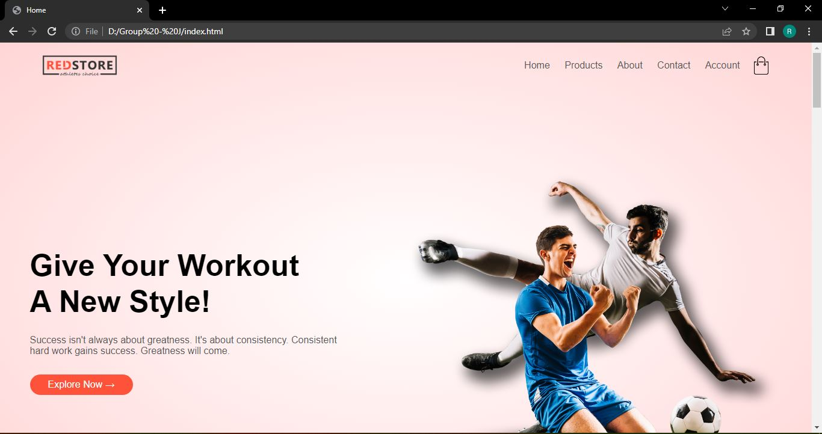

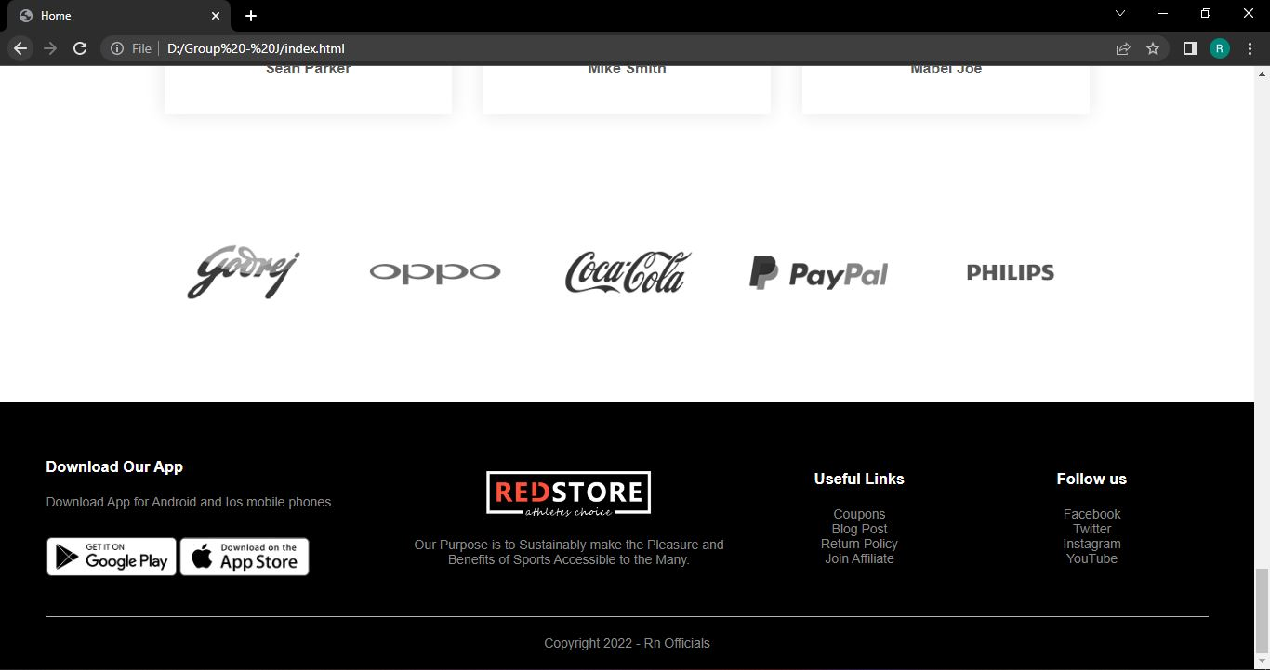

**Product.html**

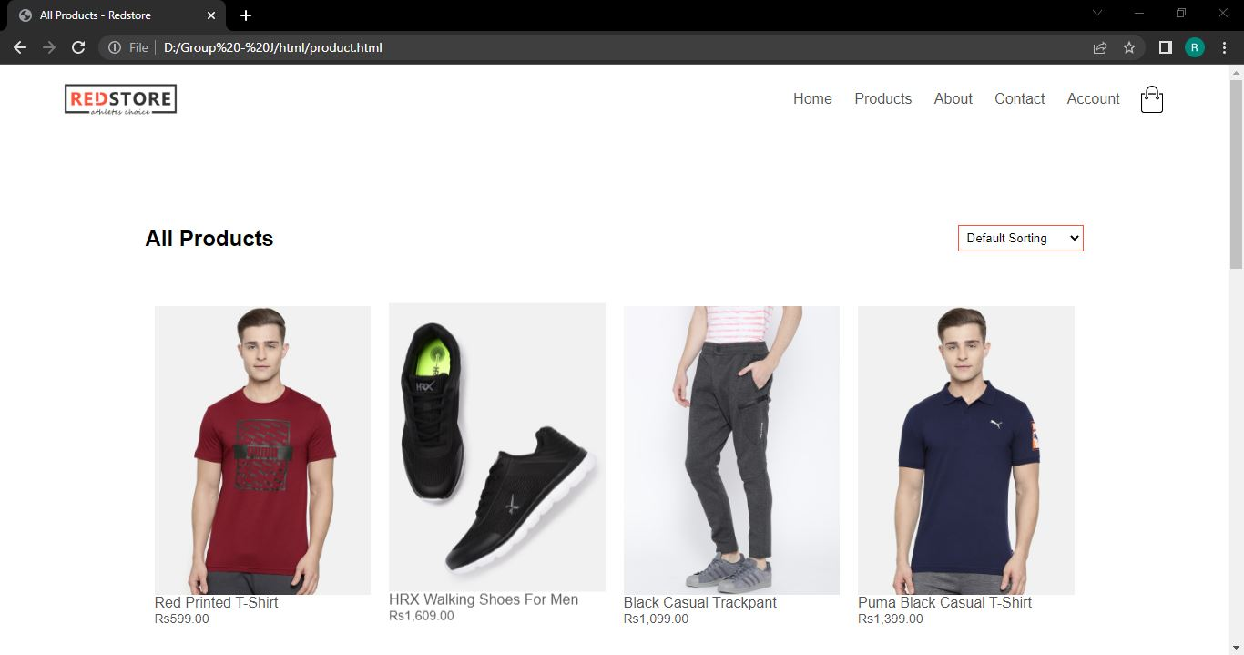

**Product Details.html**

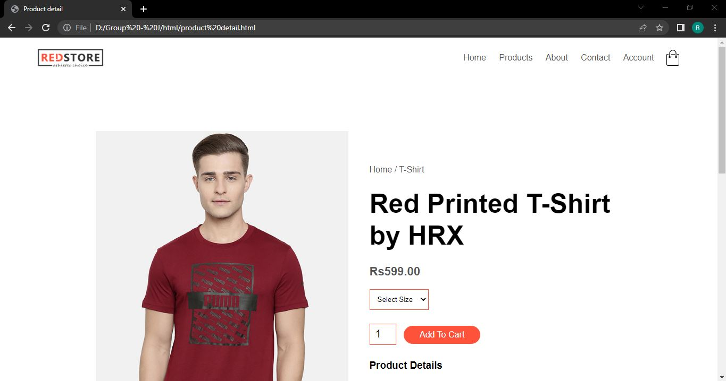

**About.html**

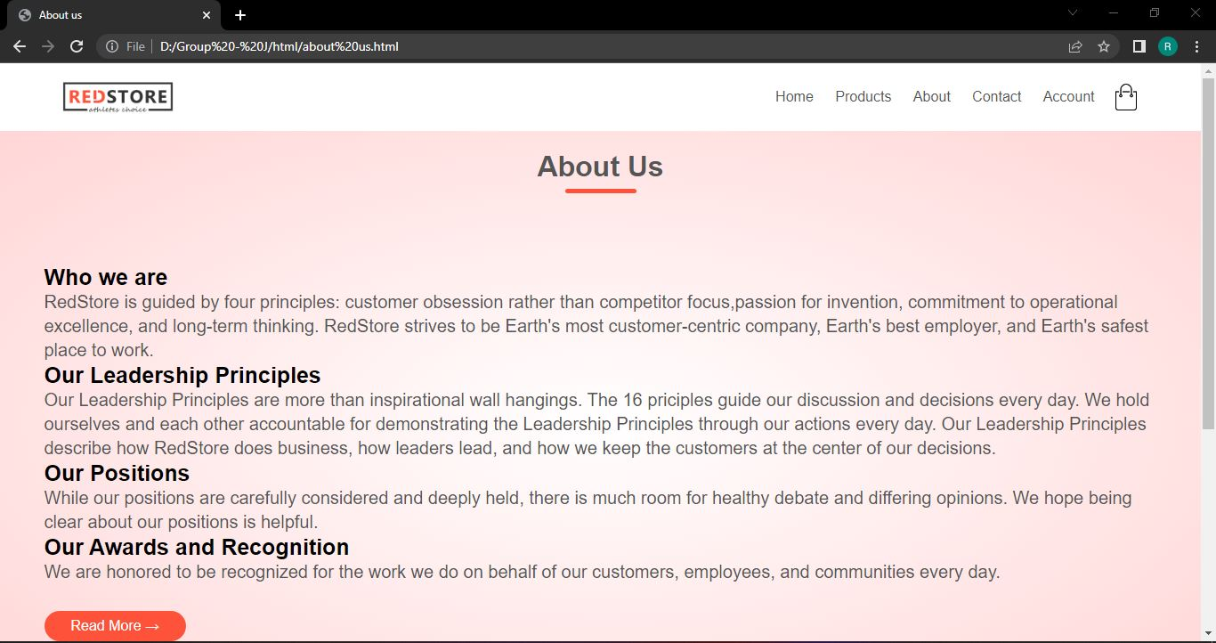

**Contact.html**

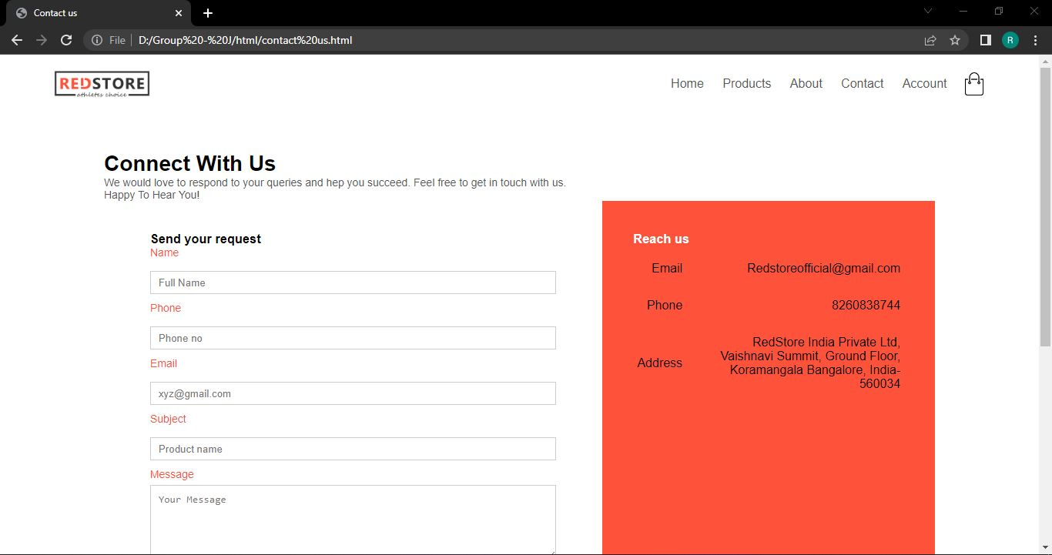

**Account.html**

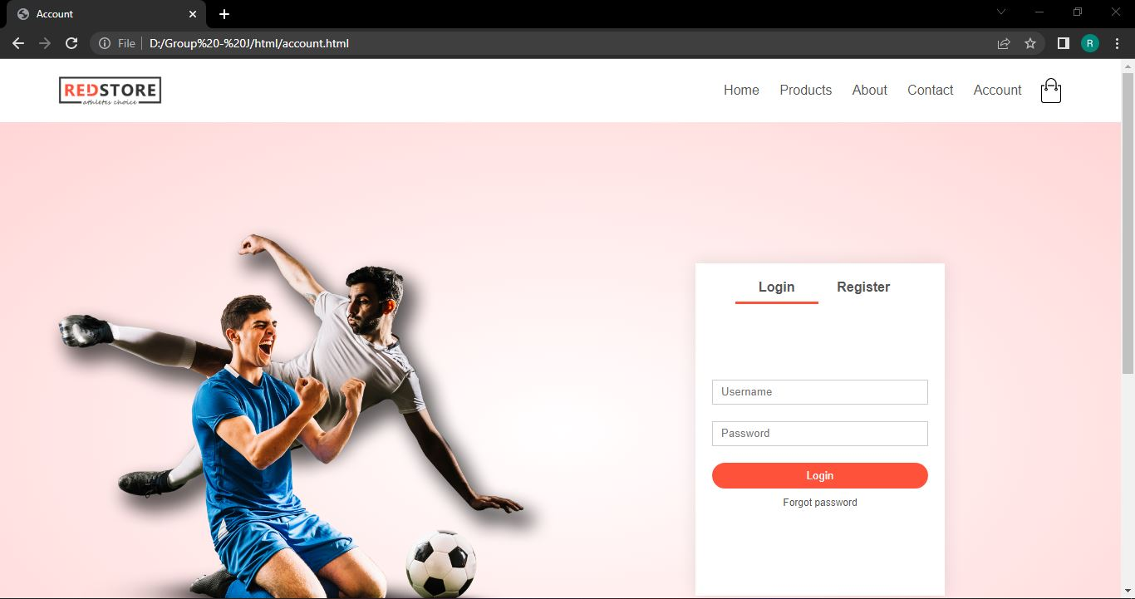

**Cart.html**

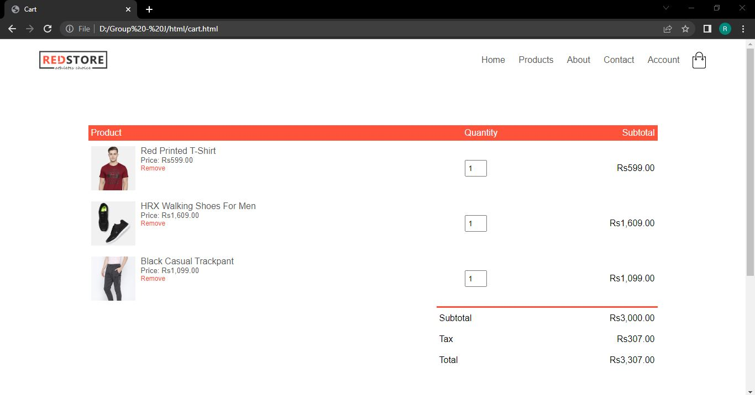

**CONCLUSION**

It has been a matter of immense pleasure, honour, and challenge to have this opportunity to take up this project and complete it successfully.

While developing this project we learned a lot about an Online Shopping Site and also how to make it user-friendly, engaging and eye catching by hiding the complicated parts of it from the users. During the development process, we carefully studied and understood the criteria for making web pages. We also realized the importance of maintaining a minimum margin of error through this project.

This project will be very much helpful for the students to make their static website using mark-up language.

With help of this project we learned various tags, attributes, style concepts etc. This project was helpful to enhance our knowledge about this topic.

Thus, our project on “Online shopping Site” is herewith submitted.

**BIBILIOGRAPHY**

While working on this project, we got to know more about HTML & CSS from various sources.

**SOURCES USED FOR THIS PROJECT:**

* www.W3Schools.com
* YouTube
* Notes provided by SeeNet
* Google.com

**SYSTEM REQUIREMENTS:**

* Operating System: Windows 10 & windows 11
* Processor: Inter Celeron core
* Memory: 6GB
* Platform: Notepad, Google chrome Browser
* Ms Word
* Notepad
* Snipping tool
* Google chrome browser
* Adobe Photoshop